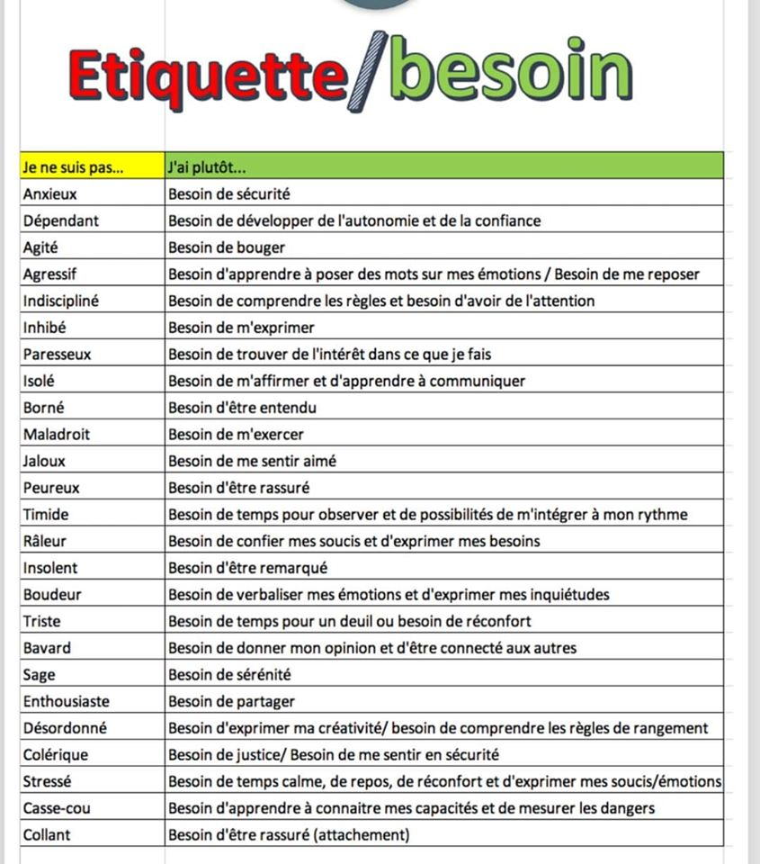Source : Aller au-delà des étiquettes pour comprendre les besoins des enfants...

Via [La page TDAH](https://www.facebook.com/PageTDAH/?__xts__%5B0%5D=68.ARBWqJz2wAr7k-8nV4FLS4dfRN5-w6MhVK_BM5_g04qr6KoQZ-ZNijxAInEijHgdsP06RnDsnEwoKIRithsmXW1OeWC-pi9Sbae0toOEljqzQEXTw8HfDUIb_AZqwYP_tP_HEezVsWppRo9DUcJTcG9F3lNqUC-0pQiLuO-JngNDqqUEpTBwbLeLzf0p-IaEO-1Y-bskAzHLpxehA4FmzgZr9K0PKvZ3kQmT2b2p1IseqK8_U5KBXsJsMc9un4kuZtDoCxAbpzM8I2OfY7boz6UrJ6YKA-3jH69Av1yfvZnxnrC-oonMCWK9SBc7mEhw1UulPmcZqBXDz8Tex0fYx64pnLpDjl1qUSl6d6yZ8sBiFwdjiTERW9pPwayGn6AeugndSsieC2awbO7zEbejJLwYs3kr1AaC3Ud2Xsb-pJhkR0tIkvCUuAkQ96tUfXJGxCxyeORTuTjaShbYGmH_E3QM6TDf78wJZRfe6ZzLkNSS28h7AKd4IdU&__xts__%5B1%5D=68.ARDgw-ILFXUTk-1i-UwFzpAknxxZC2iVW3uaGRFJl8T6zY6uR6dAArOED1_SBNRvyJiTuk7SegRm1SCHDB5xVHOo1WvBQ2voBi8Aq4epBuEHVCyt_vKi-9P9FX2zNPeeyNKxPYsOlghPDsBGGSX4ibeQZepmwWAiPLz9GaAyiHGkLGD_prGSk43bdOyZZuGt9InR2cVBqQ-jlgexR4fjitel7yayJj9qeLTQWSi-nFmUvdUNUFOKxWRMEz9ErjWcTF3l_Mg22hq0hFfwZrQ9YzX-otlU4r1dKKIHj2hNdyVWam1mYDsktg4TkrDQkpH8IkuzWYvVsoN8iRX-Nakd&__tn__=K-R&eid=ARDqLnWQ1KchKRSkwxOB_qvljUtpFy8tA8YW_I0xCBaFCXV4ndLppGwdg41Gs-92oEFP-KCy6mjiK7A5&fref=mentions) Facebook